**TRAFFIC MONITORING SYSTEM**

A PROJECT REPORT

*Submitted by*

|  |  |
| --- | --- |
| CB.EN.U4CSE17014 | CH.JASWANTH |
| CB.EN.U4CSE17037 | G.MAHESH |
| CB.EN.U4CSE17009  CB.EN.U4CSE17024 | ARVIND KUMAR  GUHAN RAM |

***in partial fulfilment for the award***

***of grade for the course***

**15CSE302 Database Management Systems**



**DEPARTMENT OF COMPUTER SCIENCE AND ENGINEERING**

**AMRITA SCHOOL OF ENGINEERING, COIMBATORE**

**AMRITA VISHWA VIDYAPEETHAM**

**COIMBATORE 641 112**

**ACKNOWLEDGEMENT**

We would like to thank the Pro Chancellor **Brahmachari Abhayamrita Chaitanya**

Vice Chancellor **Dr. P. Venkat Rangan and Dean Dr. Sasangan Ramanathan** for having provided the necessary infrastructure required for the completion of the project.

We are grateful to **Col P.N.Kumar**, Chairperson, Department of Computer Science and Engineering for providing an opportunity to do this project.

We express our deepest gratitude to our faculty **Mrs.O.K.Sikha** for the invaluable guidance and encouragement throughout the project. Without her support and helping hand, this project would never have been a success.

We sincerely thank all the teaching and non-teaching staff members who have helped us in our work during this project.

We owe all our knowledge to all the teachers who taught us and cared for us, they are our true well-wishers. It’s their blessing that catapulted us through the way of success. We owe them all a piece of our heart. We wouldn’t be happier than to be known as their student.

Last but not the least, our sincere thanks to all of our parents and friends who have patiently extended all sorts of help for completing this project. We could not have successfully completed our project without the blessings of our respected chancellor beloved **Amma**.

**TABLE OF CONTENTS**

◆▪Chapter 1: ABSTRACT…………………………………………..4

◆▪Chapter 2:PREVIEW……………………………… …………….5 - 6

◆ INTRODUCTION

◆ PROJECT DESCRIPTION

◆ MODULES

◆▪Chapter 3:RELATIONAL SCHEMA ….………...........................7

◆▪Chapter 4:ENTITY RELATIONSHIP DIAGRAM …………….....8

◆▪Chapter 5:EXTENDED ENTITY RELATIONSHIP DIAGRAM…9

◆▪Chapter 6:NORMALIZATION………………………………10-13

◆▪Chapter 7:TABLE CREATION…………………………………14

◆▪Chapter 9: USER INTERFACE ……………….………………..15

◆▪Chapter 10:BACK END CODE ……………….………………..16-24

◆▪Chapter 9:CONCLUSION AND REFERENCES……………..25

**ABSTRACT**

Traffic is increasing day by day due to the increase in vehicle usage especially in urban areas. Congestion in traffic also increases with the increase of vehicle numbers. To regulate the flow of vehicles we are presently using traffic light controllers which have three signals. With the help of these signals we can regulate the vehicle direction. Most of the controllers have a fixed duration for each of the three signals which may lead to the additional congestion in traffic. This congestion we can be avoided in two ways. One way is to design an intelligent traffic light controller which alters the duration between each signal. Other is to make the user of the vehicle aware of the traffic density of the path in which he is travelling. In this way different solutions have been proposed to make the traffic system smarter, reliable and robust. The aim of this project is to design and develop the database for traffic monitoring system to reduce the traffic congestions and road accidents.

**PREVIEW**

**INTRODUCTION**

The number of fatalities due to road accidents in India has been consistently above one lakh every year. Although the fatality index and rates are declining the actual figure is still at an alarming stage. In order to help in reducing the number of road accidents and fatalities, the availability of reliable and comprehensive road accident database and analysis system is critical to understand the pattern of accident causation. We believe that better structured data will create conditions for deeper analysis aiding in the formulation of evidence based research on road safety in enabling better road safety intervention and performance monitoring. In this project we are providing statistical analysis for different users to examine the cause for the problem by creating an app based interface where the raw data will be manipulated by a database management system in the back end.

**PROJECT DESCRIPTION**

In traffic monitoring system, there are many factors under consideration like vehicle type (Emergency vehicle, Ordinary vehicles, stolen vehicles), types of roads (highways, roads under construction, normal roads) by knowing details like road id, town and junction ID. We are also provided with the details of traffic on a day-to-day basis for each road. According to the report details, the user can choose the best possible route which has less traffic congestion. Based on the history details, this system develops timeslot functionality which suggests the user to travel TO and FRO based on the time stamp. It also keeps a record of registered vehicles.

**MODULES:**

This system includes the following modules

· Interface creation for traffic monitoring system

· Maintaining the details of roads under construction

· Maintaining record of violations

· Provides details about the respective road signals

· Maintain contact details of vehicle owners (Domestic and Emergency)

**UI :** Android Studio

**DBMS :** SQLite

**RELATIONAL SCHEMA**

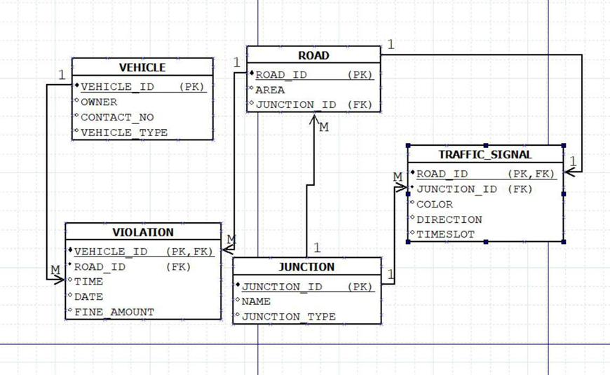

**ENTITY RELATIONSHIP DIAGRAM**

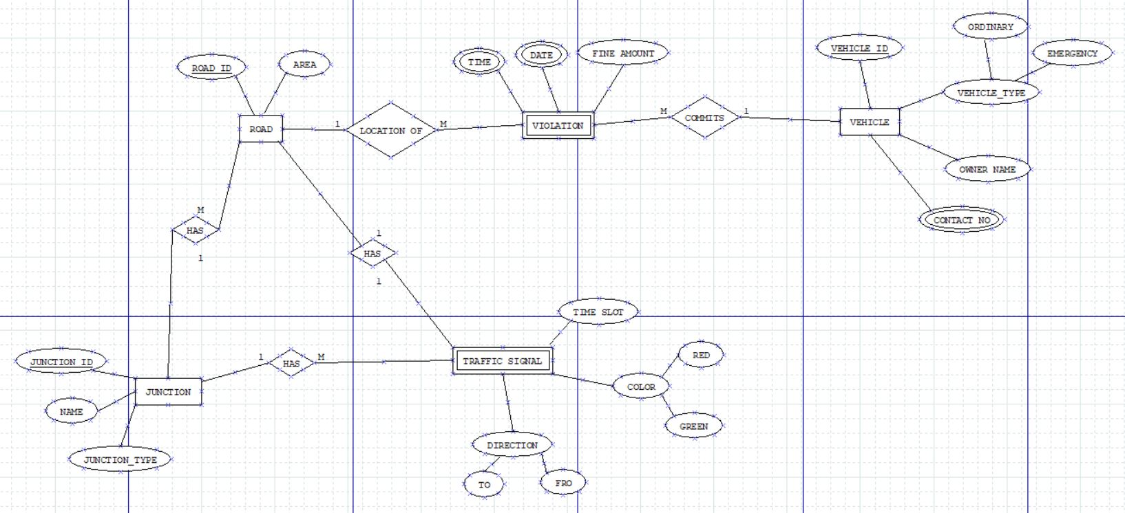

**EXTENDED ENTITY RELATIONSHIP DIAGRAM**

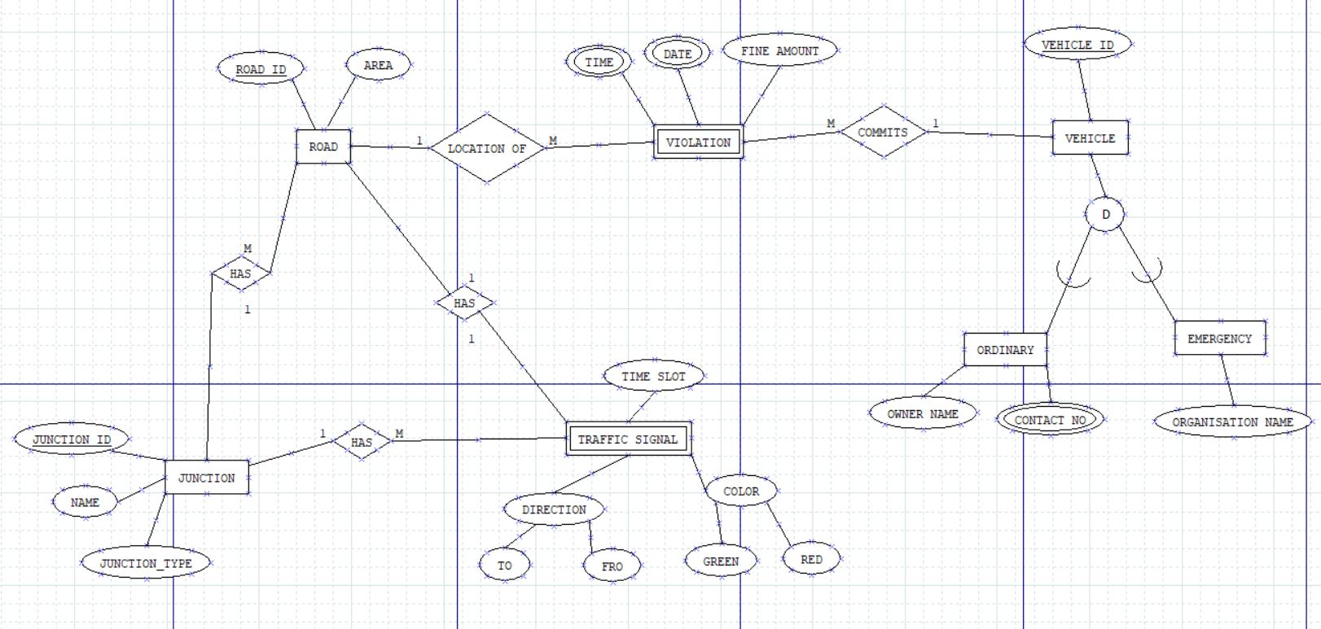

**NORMALISED SCHEMA**

* R1(**Vehicle_id**,  Vehicle type, Owner ,Contact no , Road_id ,Area ,Time ,Date , Fine_amount).
* R2(**Road_id** , Area , Junction_id, Color,Direction,Timeslot)
* R3(Junction_id, Name ,Junction type).

**NORMALIZATION**

**RELATIONAL SCHEMA:**

R (Vehicle_id, Vehicle type, Owner ,Contact no , Road_id ,Area ,Time ,Date , Fine_amount , Junction_id ,Name ,Junction type ,Color,Direction,Timeslot ).

**Functional Dependencies:**

Vehicle_id 🡪 Owner ,Contact no , Road_id ,Area ,Time ,Date , Fine_amount

Road_id 🡪 Area , Junction_id, Color,Direction,Timeslot

Junction_id 🡪 Name ,Junction type

Candidate key= { Vehicle_id }

**1-NF: (First Normal Form)**

There are Three multivalued or composite attributes in the table. Namely Time,Dates,Contact no. But an attribute of a table cannot hold multiple values. It should hold only atomic values. So split it into 2 different tuples(repeat the tuple with the multiple valued attribute).

Given Table R is in 1-NF.

**2-NF: (Second Normal Form)**

The table is in 1-NF.

The table doesn’t consists of any partial dependencies among Functional dependencies. No non-primary attribute is dependent on the proper subset of any candidate key of table.

Given Table is in 2-NF.

**3-NF: (Third Normal Form)**

The table is in 2-NF

The table consists of Transitive dependencies. So Transitive dependencies of no primary attribute on any super key should be removed.

Now decompose the tables in such a way, it ensures the connectivity in resulting tables through (FK,PK) pair.

So the tables will be:

* R1(**Vehicle_id**, Vehicle type, Owner ,Contact no , Road_id ,Area ,Time ,Date , Fine_amount).
* Functional dependency

Vehicle_id 🡪 Owner ,Contact no , Road_id ,Area ,Time ,Date , Fine_amount

* R2(**Road_id** , Area , Junction_id, Color,Direction,Timeslot)
* Functional dependency

Road_id 🡪 Area , Junction_id, Color,Direction,Timeslot

* R3(Junction_id, Name ,Junction type)
* Functional dependency

Junction_id 🡪 Name ,Junction type

The Tables are **R1, R2,R3.**

The Given table is in **3-NF.**

**BCNF: (Boyce code Normal Form)**

The Table is in 3-NF.

For any FD, say A🡪B , A must be candidate key.

Here in R1 Vehicle_id is a candidate key.

R2 Road_id is a candidate key.

R3 Junction_id is a candidate key.

The given tables are in **BC-NF**

So, No of tables after Normalization are:

* R1(**Vehicle_id**, Vehicle type, Owner ,Contact no , Road_id ,Area ,Time ,Date , Fine_amount).
* R2(**Road_id** , Area , Junction_id, Color,Direction,Timeslot)
* R3(Junction_id, Name ,Junction type).
* UI creation done via ***android***

**TABLE CREATION**

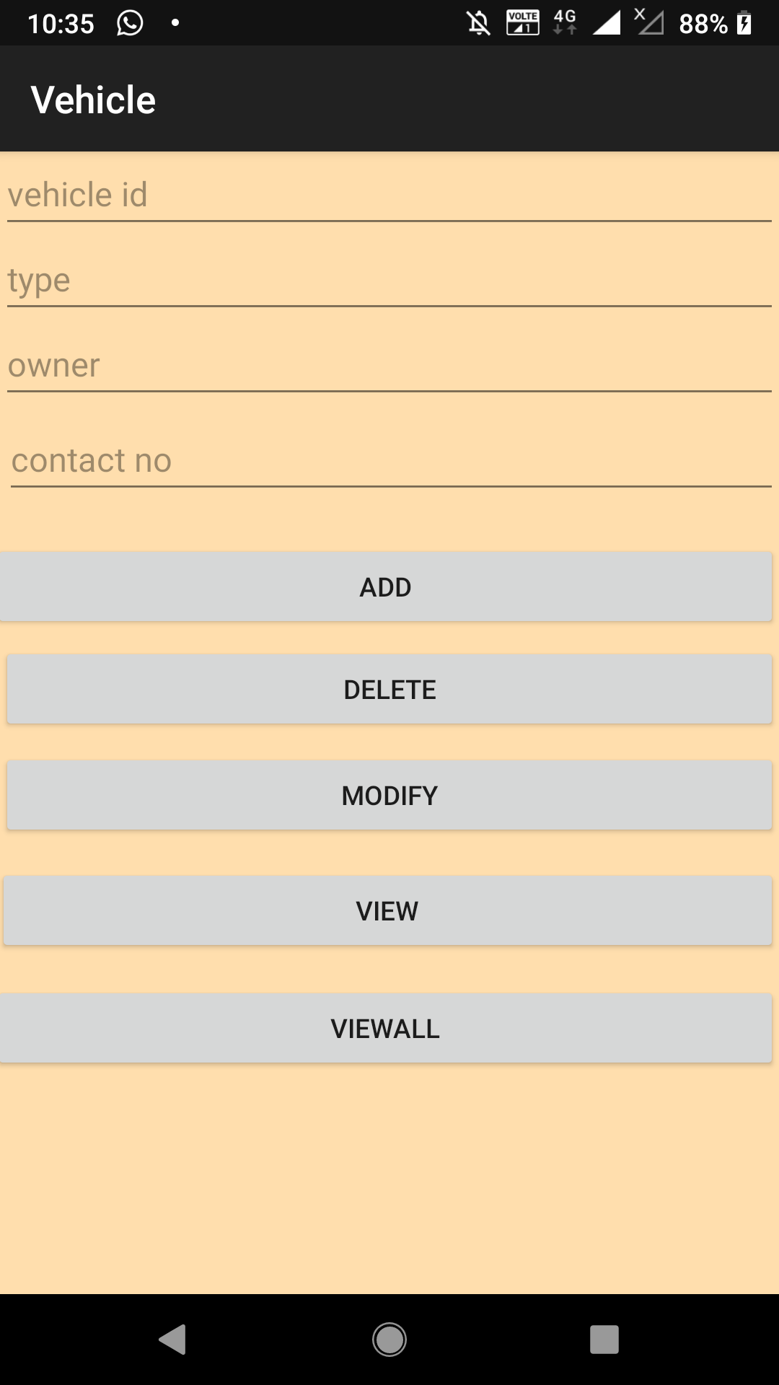 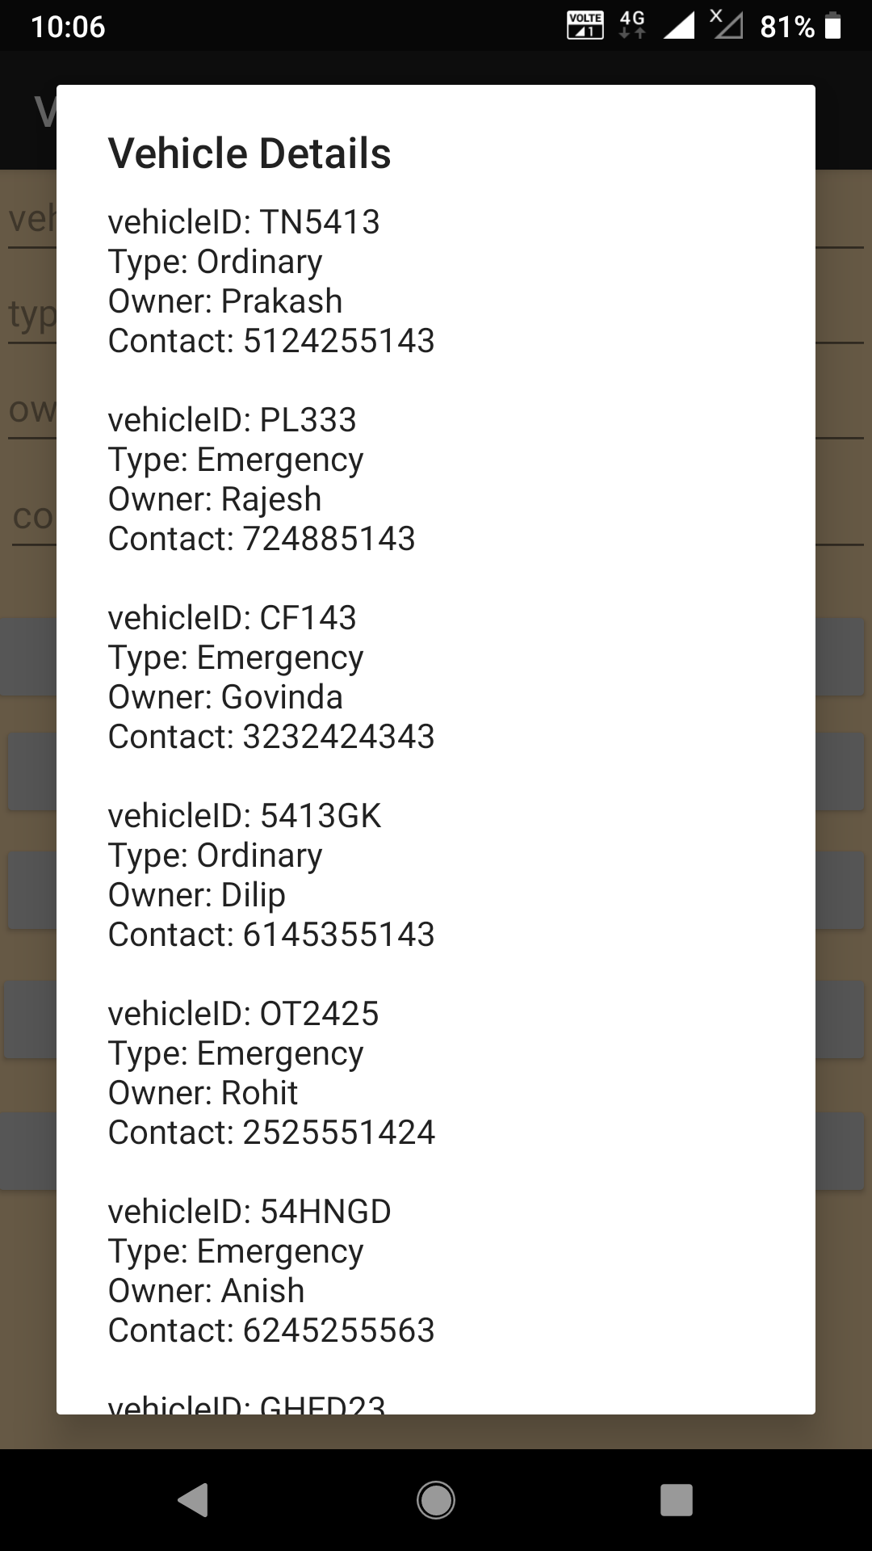

**USER INTERFACE**

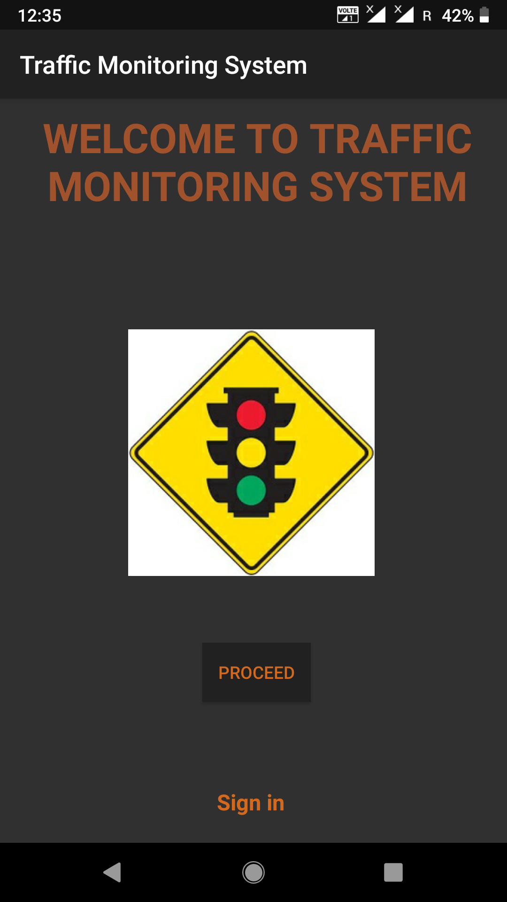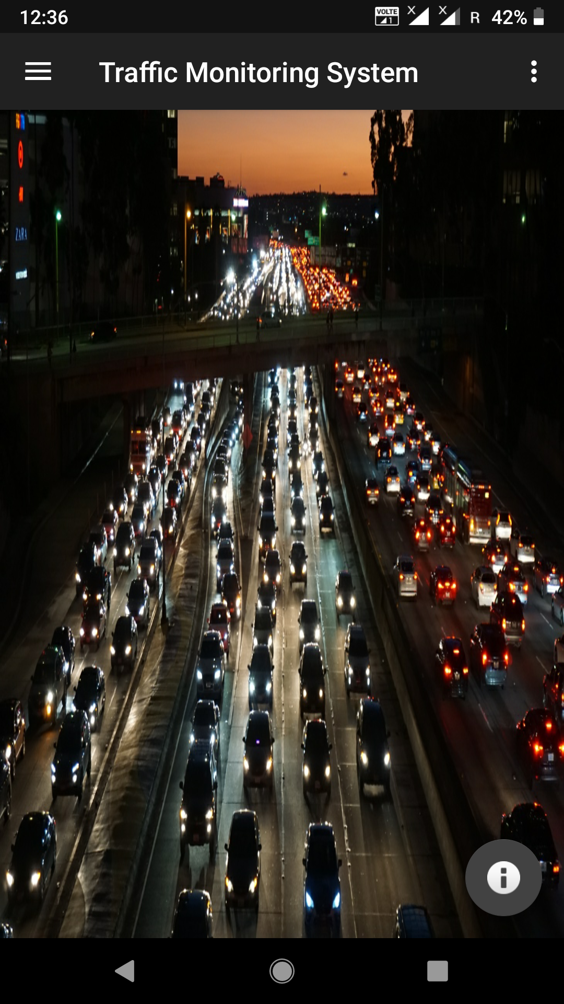

**BACKEND CODE (JAVA)**

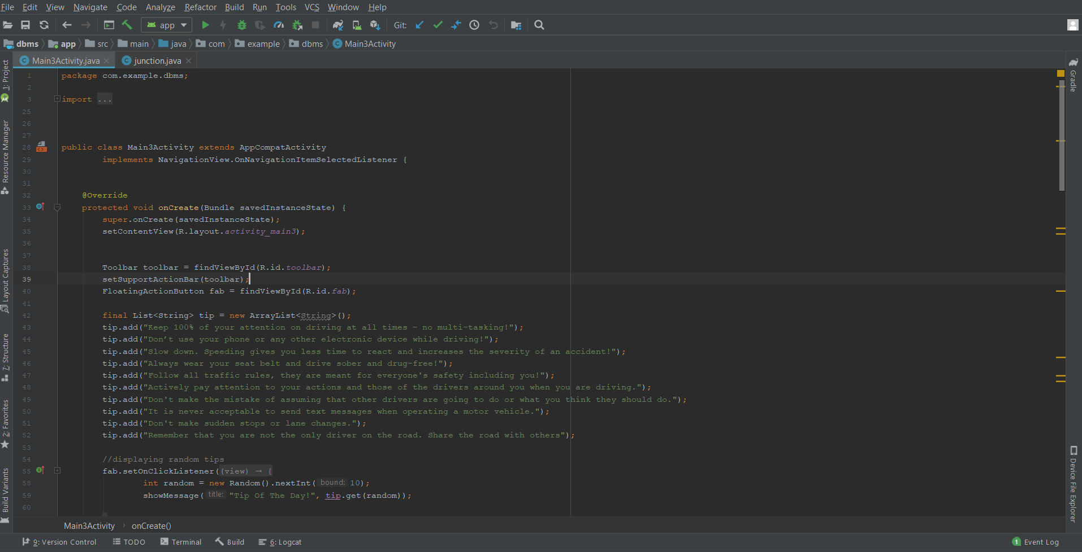

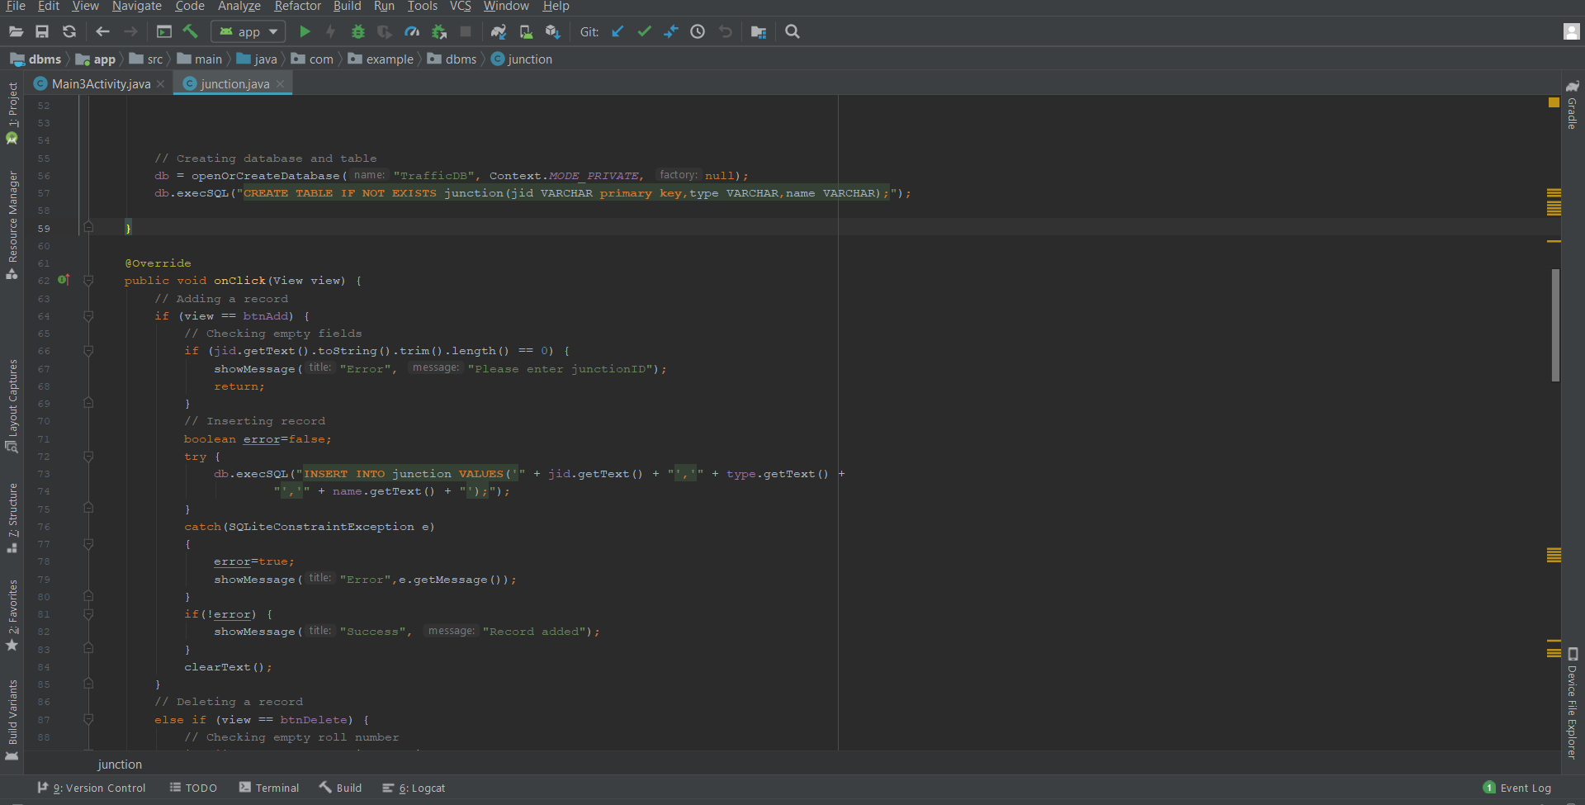

**USER INTERFACE CODE(XML)** 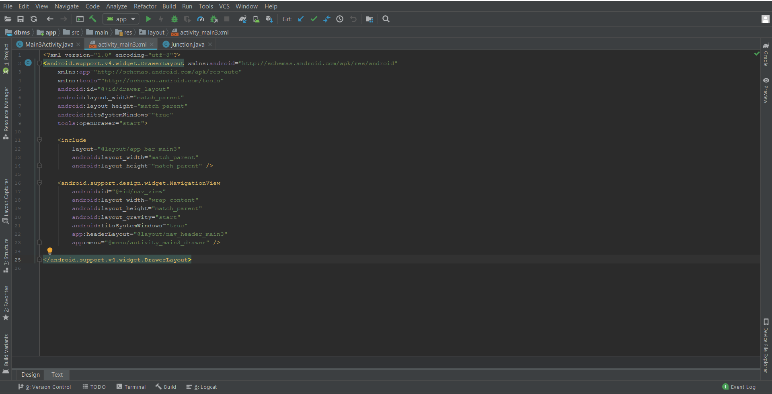

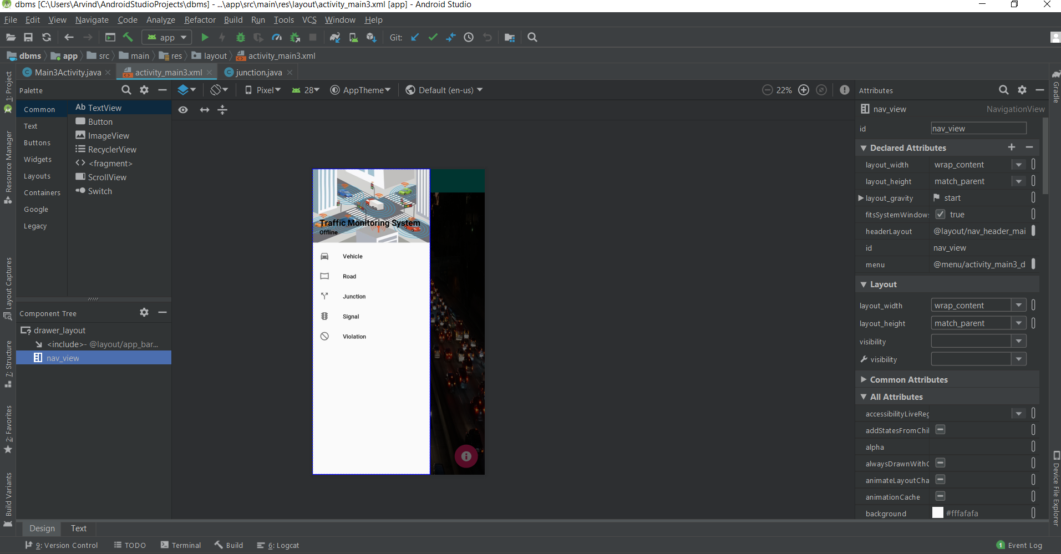

**Java Code for Main Page**

**package com.example.dbms;**

**import android.content.Context;**

**import android.content.Intent;**

**import android.content.SharedPreferences;**

**import android.os.Bundle;**

**import android.support.design.widget.FloatingActionButton;**

**import android.support.design.widget.Snackbar;**

**import android.support.v7.app.AlertDialog;**

**import android.view.View;**

**import android.support.v4.view.GravityCompat;**

**import android.support.v7.app.ActionBarDrawerToggle;**

**import android.view.MenuItem;**

**import android.support.design.widget.NavigationView;**

**import android.support.v4.widget.DrawerLayout;**

**import android.support.v7.app.AppCompatActivity;**

**import android.support.v7.widget.Toolbar;**

**import android.view.Menu;**

**import android.widget.TextView;**

**import java.util.ArrayList;**

**import java.util.List;**

**import java.util.Random;**

**public class Main3Activity extends AppCompatActivity**

**implements NavigationView.OnNavigationItemSelectedListener {**

**@Override**

**protected void onCreate(Bundle savedInstanceState) {**

**super.onCreate(savedInstanceState);**

**setContentView(R.layout.activity_main3);**

**Toolbar toolbar = findViewById(R.id.toolbar);**

**setSupportActionBar(toolbar);**

**FloatingActionButton fab = findViewById(R.id.fab);**

**final List<String> tip = new ArrayList<String>();**

**tip.add("Keep 100% of your attention on driving at all times – no multi-tasking!");**

**tip.add("Don’t use your phone or any other electronic device while driving!");**

**tip.add("Slow down. Speeding gives you less time to react and increases the severity of an accident!");**

**tip.add("Always wear your seat belt and drive sober and drug-free!");**

**tip.add("Follow all traffic rules, they are meant for everyone's safety including you!");**

**tip.add("Actively pay attention to your actions and those of the drivers around you when you are driving.");**

**tip.add("Don't make the mistake of assuming that other drivers are going to do or what you think they should do.");**

**tip.add("It is never acceptable to send text messages when operating a motor vehicle.");**

**tip.add("Don't make sudden stops or lane changes.");**

**tip.add("Remember that you are not the only driver on the road. Share the road with others");**

**//displaying random tips**

**fab.setOnClickListener(new View.OnClickListener() {**

**@Override**

**public void onClick(View view) {**

**int random = new Random().nextInt(10);**

**showMessage("Tip Of The Day!", tip.get(random));**

**}**

**});**

**DrawerLayout drawer = findViewById(R.id.drawer_layout);**

**NavigationView navigationView = findViewById(R.id.nav_view);**

**ActionBarDrawerToggle toggle = new ActionBarDrawerToggle(**

**this, drawer, toolbar, R.string.navigation_drawer_open, R.string.navigation_drawer_close);**

**drawer.addDrawerListener(toggle);**

**toggle.syncState();**

**navigationView.setNavigationItemSelectedListener(this);**

**View headerView = navigationView.getHeaderView(0);**

**TextView username=headerView.findViewById(R.id.username);**

**SharedPreferences sp = getSharedPreferences("login", Context.MODE_PRIVATE);**

**if(sp.getString("status","false").equals("true")) {**

**username.setText("Welcome User");**

**}**

**}**

**@Override**

**public void onBackPressed() {**

**DrawerLayout drawer = findViewById(R.id.drawer_layout);**

**if (drawer.isDrawerOpen(GravityCompat.START)) {**

**drawer.closeDrawer(GravityCompat.START);**

**} else {**

**super.onBackPressed();**

**}**

**}**

**@Override**

**public boolean onCreateOptionsMenu(Menu menu) {**

**// Inflate the menu; this adds items to the action bar if it is present.**

**getMenuInflater().inflate(R.menu.main3, menu);**

**SharedPreferences sp = getSharedPreferences("login", Context.MODE_PRIVATE);**

**if(sp.getString("status","false").equals("true")){**

**menu.getItem(0).setVisible(true);**

**}**

**return true;**

**}**

**@Override**

**public boolean onOptionsItemSelected(MenuItem item) {**

**// Handle action bar item clicks here. The action bar will**

**// automatically handle clicks on the Home/Up button, so long**

**// as you specify a parent activity in AndroidManifest.xml.**

**int id = item.getItemId();**

**//noinspection SimplifiableIfStatement**

**if (id == R.id.action_about) {**

**startActivity(new Intent(this,about.class));**

**}**

**else if(id==R.id.action_log){**

**SharedPreferences sp = getSharedPreferences("login", Context.MODE_PRIVATE);**

**SharedPreferences.Editor edit = sp.edit();**

**edit.putString("status","false");**

**edit.commit();**

**startActivity(new Intent(this,Main2Activity.class));**

**}**

**return super.onOptionsItemSelected(item);**

**}**

**@SuppressWarnings("StatementWithEmptyBody")**

**@Override**

**public boolean onNavigationItemSelected(MenuItem item) {**

**// Handle navigation view item clicks here.**

**int id = item.getItemId();**

**if (id == R.id.nav_vehicle) {**

**startActivity(new Intent(this,vehicle.class));**

**} else if (id == R.id.nav_road) {**

**startActivity(new Intent(this,road.class));**

**} else if (id == R.id.nav_junction) {**

**startActivity(new Intent(this,junction.class));**

**} else if (id == R.id.nav_signal) {**

**startActivity(new Intent(this,signal.class));**

**} else if (id == R.id.nav_violation) {**

**startActivity(new Intent(this,violation.class));**

**}**

**DrawerLayout drawer = findViewById(R.id.drawer_layout);**

**drawer.closeDrawer(GravityCompat.START);**

**return true;**

**}**

**public void showMessage(String title, String message){**

**AlertDialog.Builder builder = new AlertDialog.Builder(this);**

**builder.setCancelable(true);**

**builder.setTitle(title);**

**builder.setMessage(message);**

**builder.show();**

**} }**

**CONCLUSION**

This project is achieved with all features promised in abstract and preview Various details of vehicles, roads, traffic signal etc. are stored and monitored to help learn the causes and frequency of traffic jams, violations in the roads etc. In case of any traffic violations, the concerned authorities can be notified accordingly. The authorities can take appropriate actions from our data monitoring app.

**References:-**

[https://developer.android.com](https://developer.android.com/)/

<https://www.tutorialspoint.com/android/android_sqlite_database.htm>

<https://www.youtube.com/watch?v=cp2rL3sAFmI>

<https://www.nationwide.com/driving-safety-tips.jsp>